Project 6 Coin Detection – 2nd Semester
Name: Pawan Jayakumar Period: 2 Date: 2/6/2020
Did you create the edge matrix? yes
Did you create the gradient direction matrix? yes
Did you identify circles? yes
Below do the following for each of the 3 images provided (so 9 images and 3 content of results.txt):
- Paste here 3 clear picture of the initial picture, the picture with the edges, the picture with the original image and the circles you detected drawn in red.
- Paste the content of your results.txt file

Hardest Difficulty:

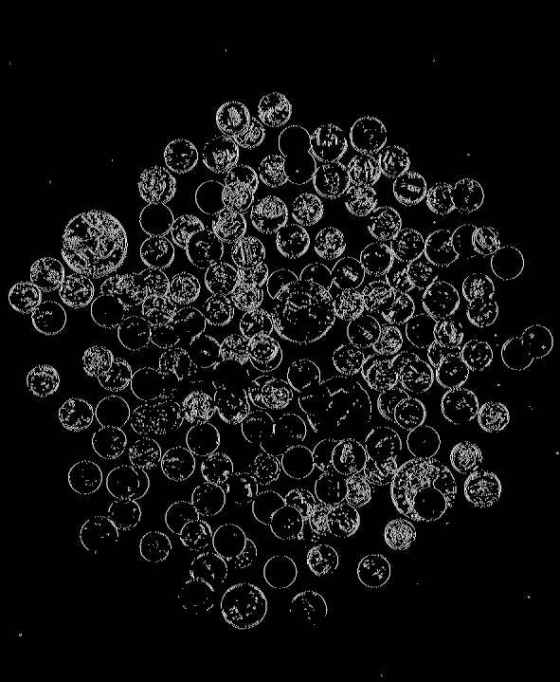
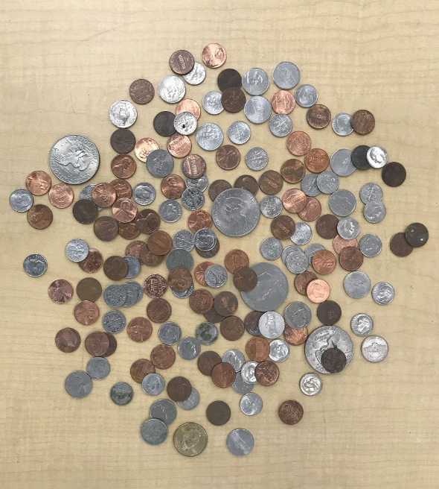
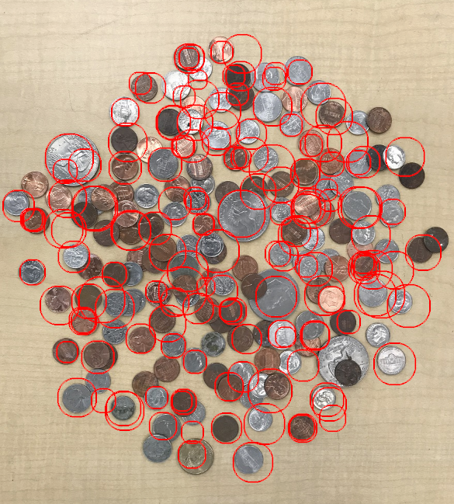

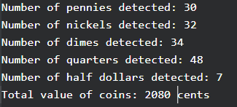

Hard Difficulty:
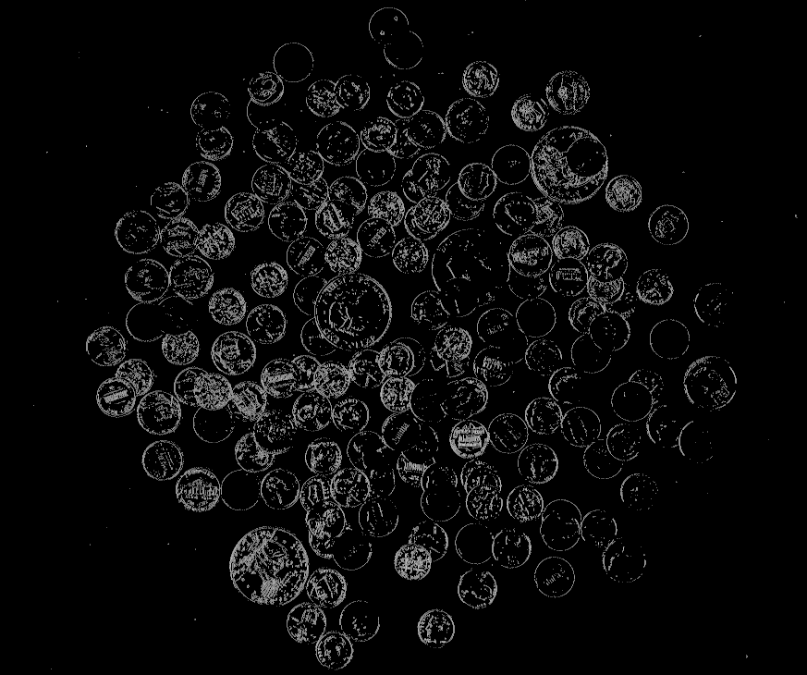
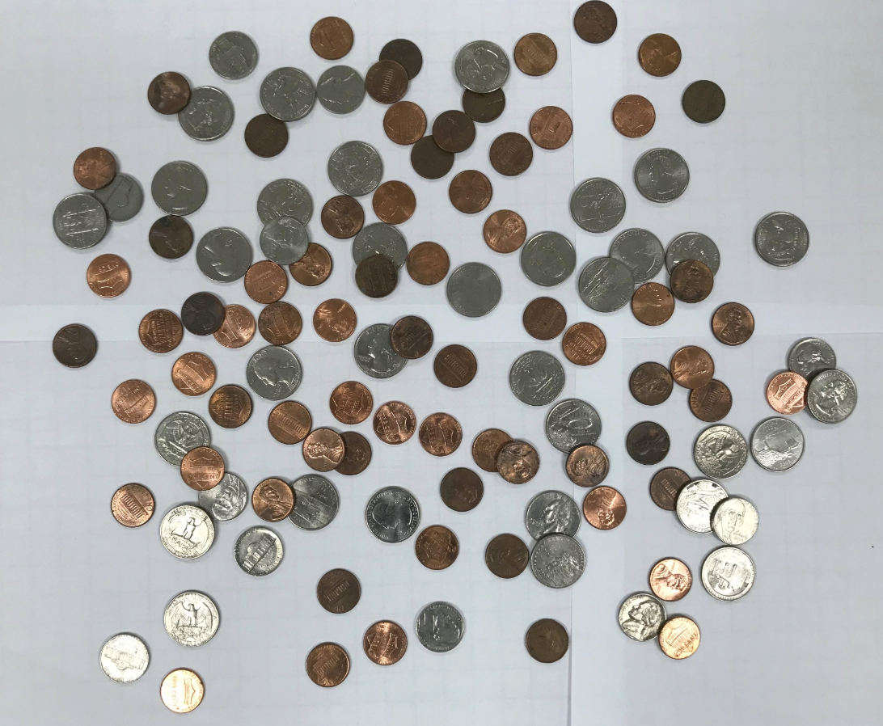
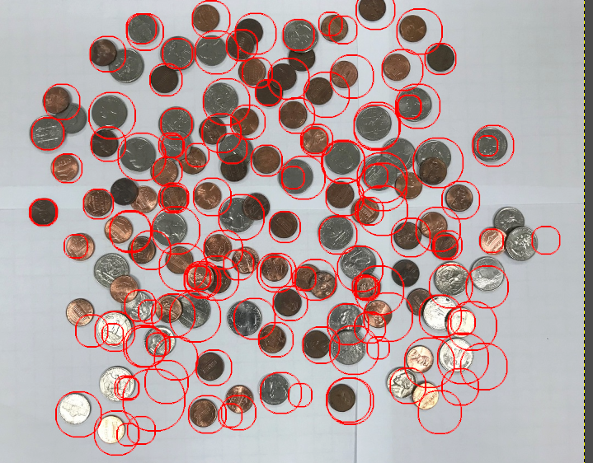

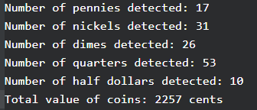

Easy difficulty:



